In this lab we will create a schedule to start and stop a Vm instance. This is a great cost saving method.

1. Go to VM Instance page>Instance schedules and click create schedule

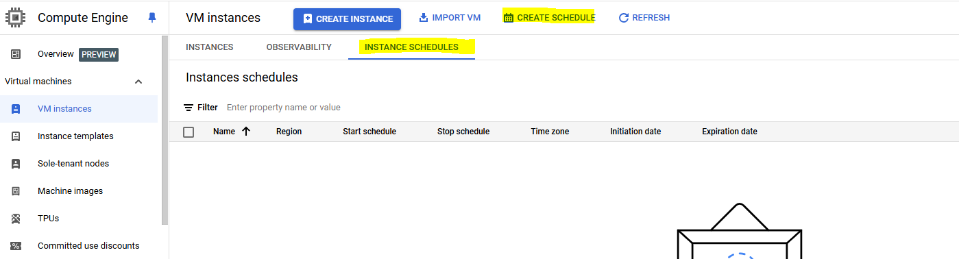

1. Fille details like name, region(same as of VM), start and stop time, time zone and date

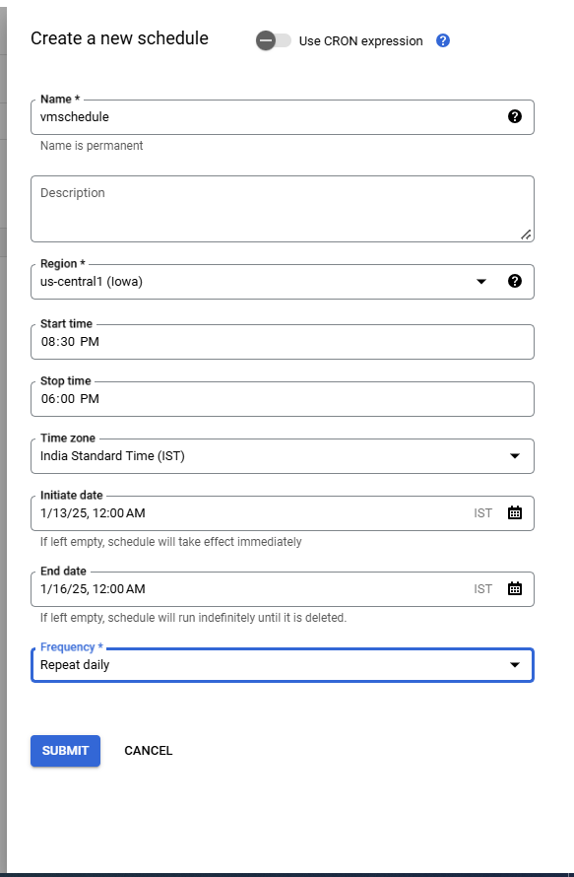

1. Now go to the schedule just created and try adding vm to it

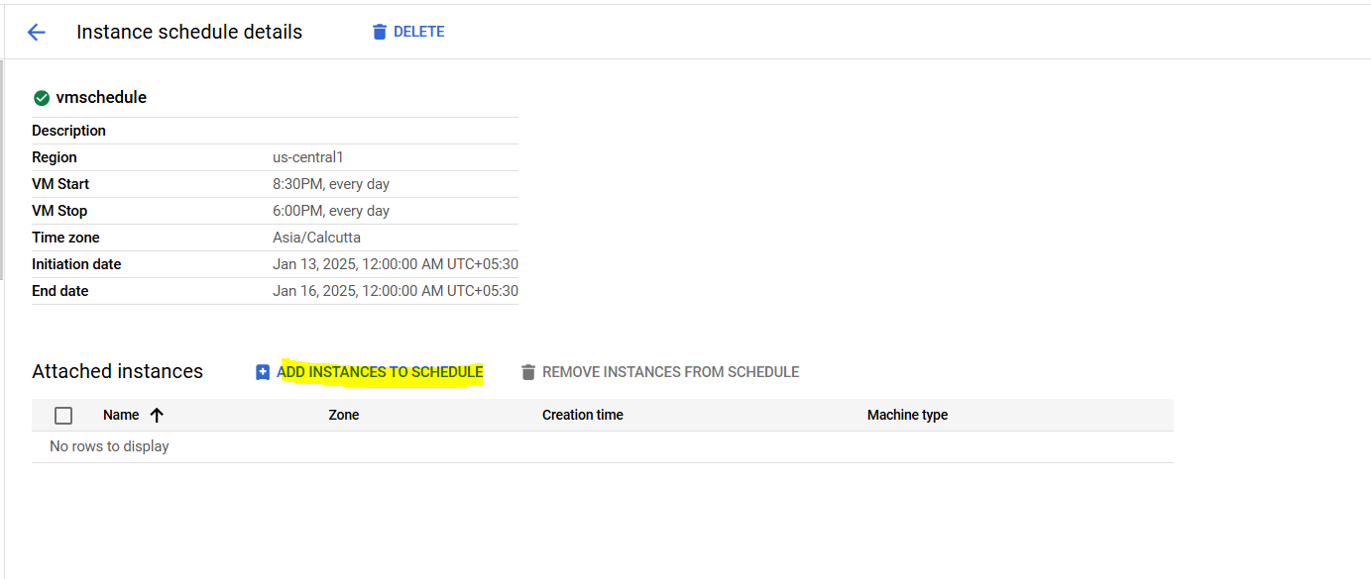

1. It should give an error like below

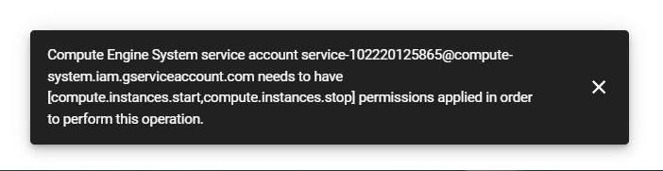

1. Now we need to provide IAM permissions to the instance to use the schedule. For that run below in the cli

gcloud projects add-iam-policy-binding REPLACE_WITH_PROJECT_ID \

--member "serviceAccount:service-xxxxxxx@compute-system.iam.gserviceaccount.com" \

--role "roles/compute.instanceAdmin.v1"

Note:- update your project ID with <replace_with_project_id> and <xxxxxxxx> meed to be replaced with compute engine system service account which can be either copied from error in previous step or from “API and identity management” page under instance

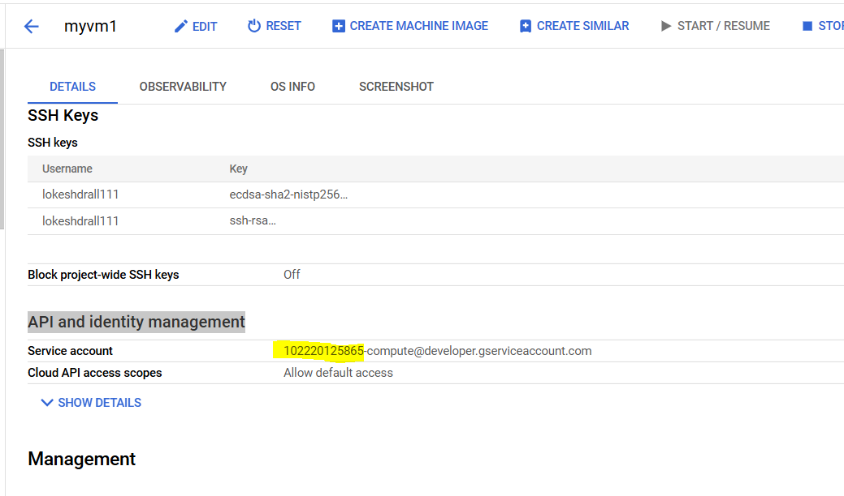

1. Open CLI and run above command

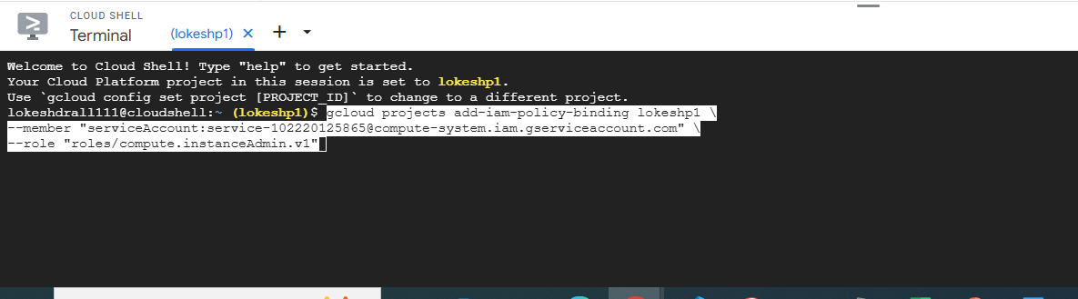

1. Once command complete successfully, try adding the vm again to schedule

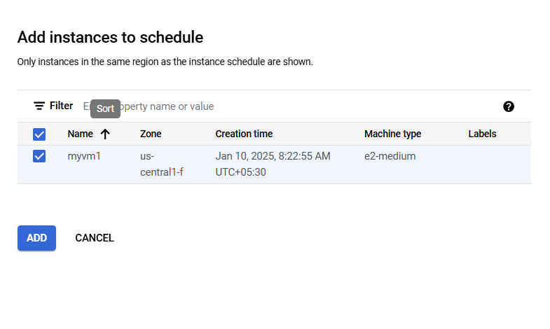

1. Now should be able to attach schedule to the VM